**LAB – 4**

Name: Gandevia Keval Dharmeshbhai

Sem: VII

Roll No: CE046

Subject: Image Processing

**Aim:** Implement following image enhancement techniques: Intensity level slicing, Bit plane slicing & Reconstruction, Histogram Equalization.

**Q. 1: Take your own photo and separate out its bit planes.**

**(a) Reconstruct your image using higher order 2-bit planes.**

**(b) Reconstruct your image using higher order 4-bit planes.**

**(c) Experiment with bit planes and derive your conclusions.**

* **Conclusion:**
* Through bit plane slicing we can reconstruct an image with one or more number of bits used for each pixel.
* If we want to reconstruct an image with 2-bit plane then we need to take the 2 higher order planes for example C8 and C7.
* By taking more and more bit planes we get more and more enhanced image.
* **Code:**

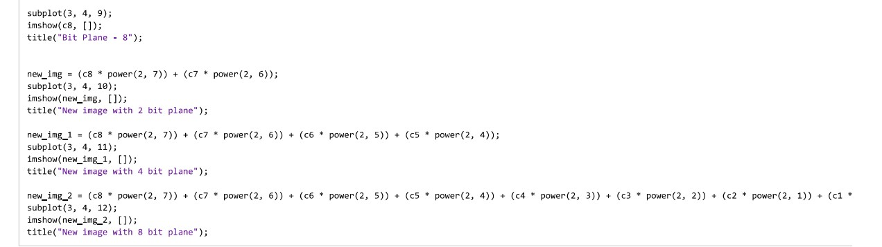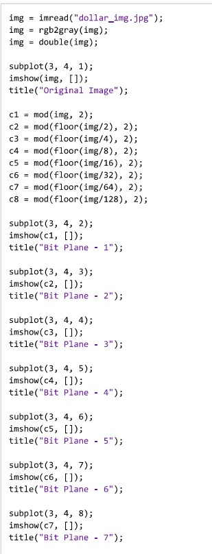

* **Output:**

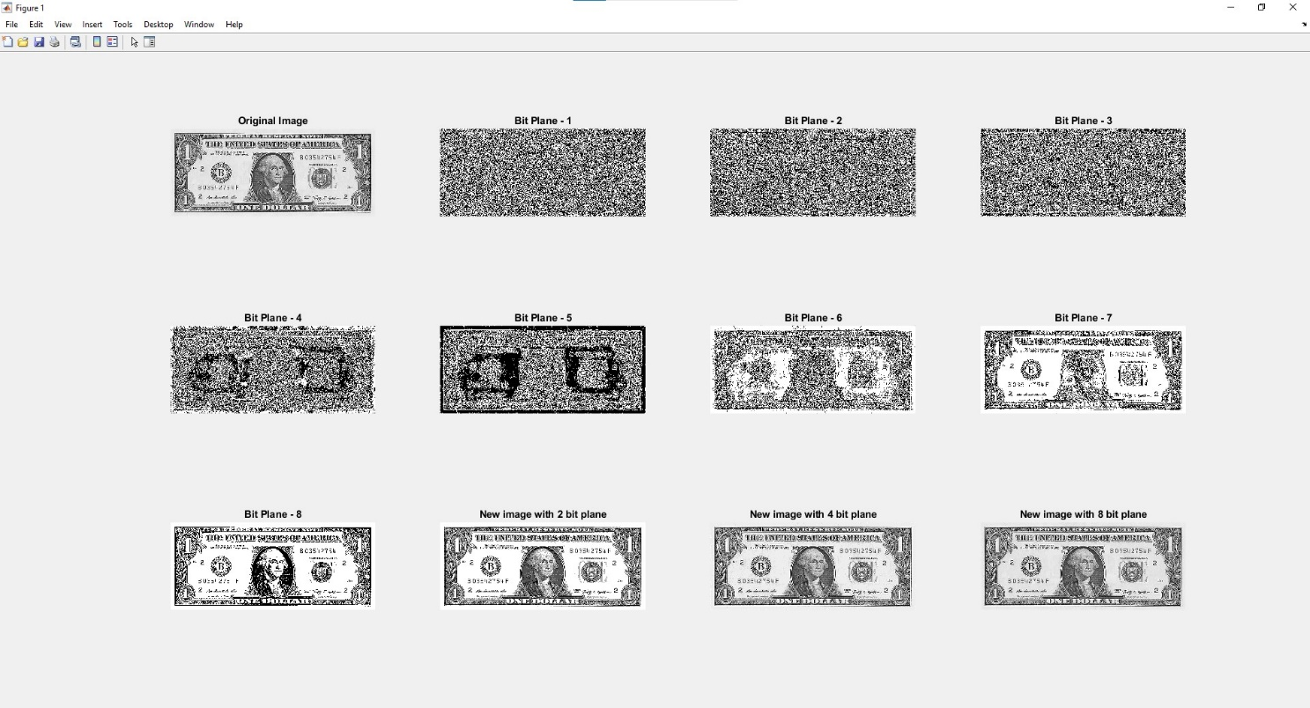

**Q. 2: Consider the image kidney.tif and perform intensity level slicing transformation within the range (150-230).**

**(a) Highlight the given intensity range and keep all other intensities to a lower level.**

* + **Code:**

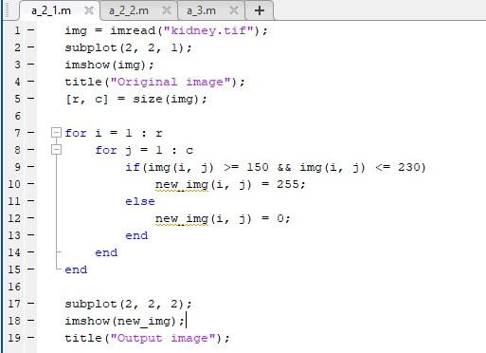

* + 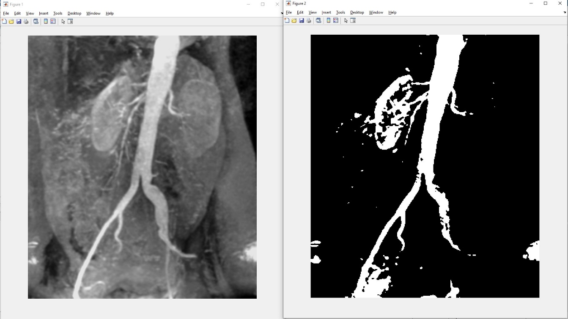**Output:**

**(b) Highlight the given intensity range and keep all other intensities as it is.**

* + 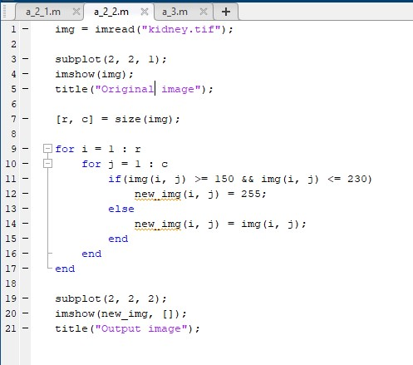**Code:**
  + **Output:**

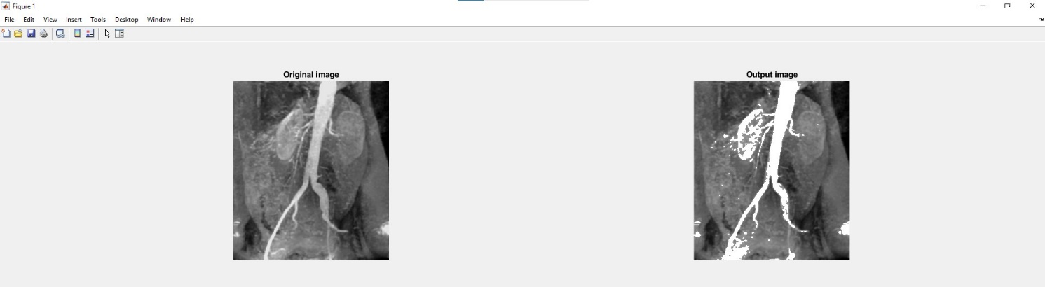

**Q. 3: Can two visually different image have same histogram? If yes synthesize two grayscale images which are visually different but having the same histogram and also show the histogram. If no justify the answer.**

* **Conclusion:**
* Certainly yes. Different images have same histogram. If we consider the different images with all of have the same white and black number of pixels then histogram of the all images would be same.
* **Code:**

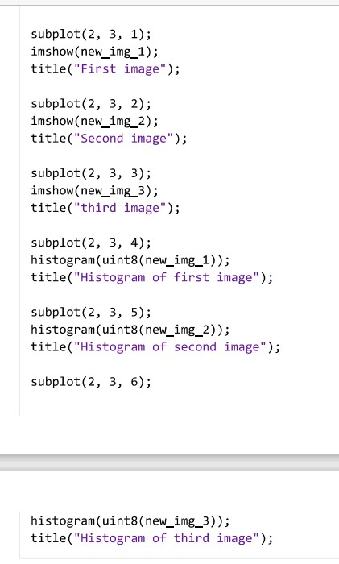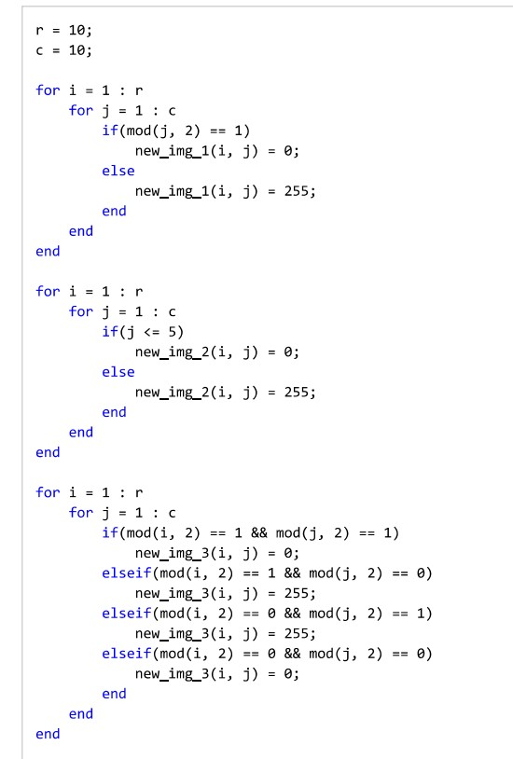

* 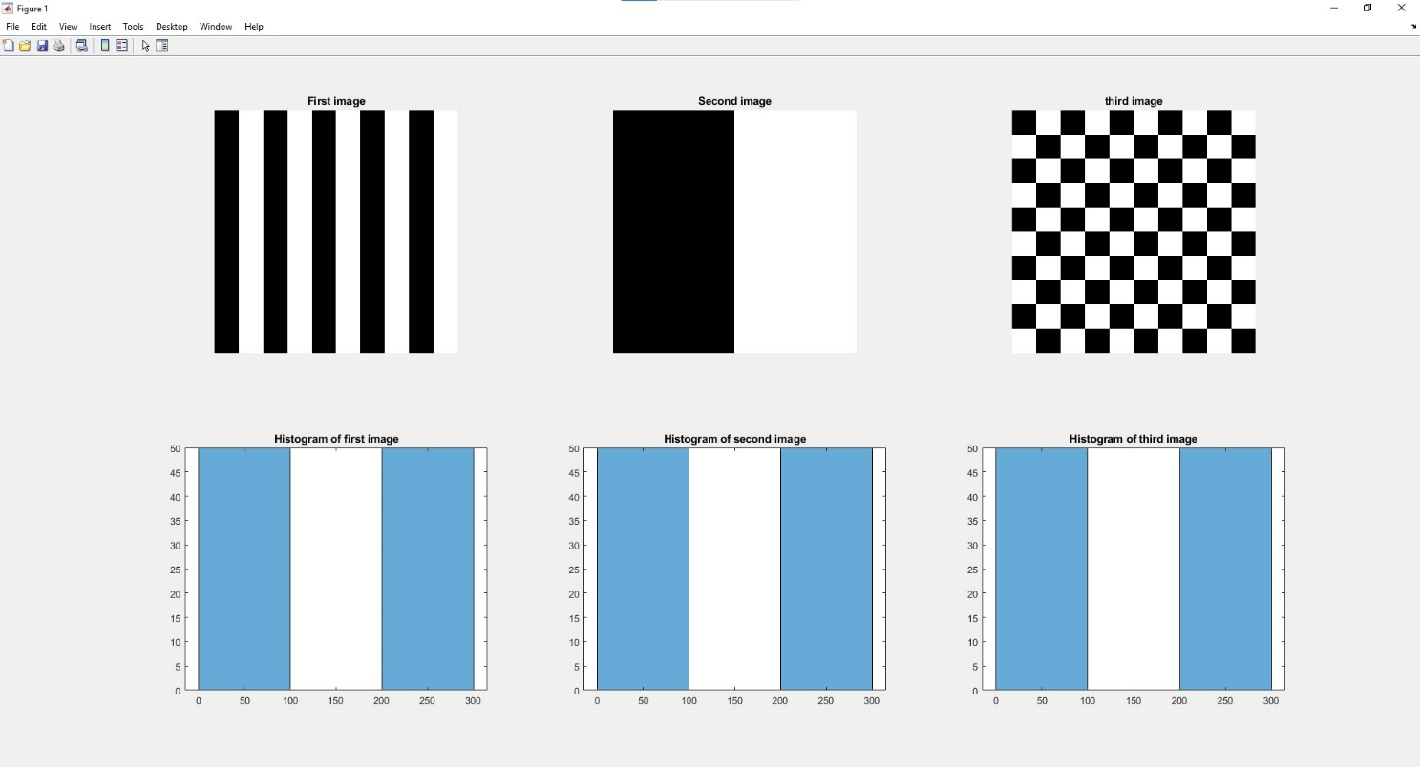**Output:**